FloodSmart.gov is designed specifically for the public and media to learn about flood risk and the importance of taking steps to financially protect homes and businesses from flood damage. Since its launch, the site has delivered on its vision to become the preferred online resource for relevant and actionable information about flood risks and flood insurance.
The three main parts of the site are Prepare, Participate and Protect. The site helps visitors learn to determine a property’s flood risk and options for protection, discover the facts about flood insurance, understand how the NFIP works in their community, and realize how to take advantage of the Insurance Center to estimate a premium and find an agent in their area.
site highlights include:
- Get the facts. Learn the basics about floods and flood insurance, to better understand your options.
- Test the waters. See how much damage a few inches of water can cause with an interactive demonstration.
- Determine your flood risk. Submit your address to receive a profile containing your property’s relative flood risk, answers to frequently asked questions, a list of insurance agents in your area and links to community information.
To see a map showing where a property is located in relation to flood hazard area, simply click on the link in your risk assessment results page.
- Get involved. Learn how community participation is the cornerstone of the National Flood Insurance Program and find ideas to mitigate and lessen your home’s flood risk.
- Find an agent. To receive a list of insurance agents in your area who sell flood insurance, simply type in your address. A list of local agents will appear instantly. You may contact a listed agent directly to ask questions or to begin the process of being covered by flood insurance.

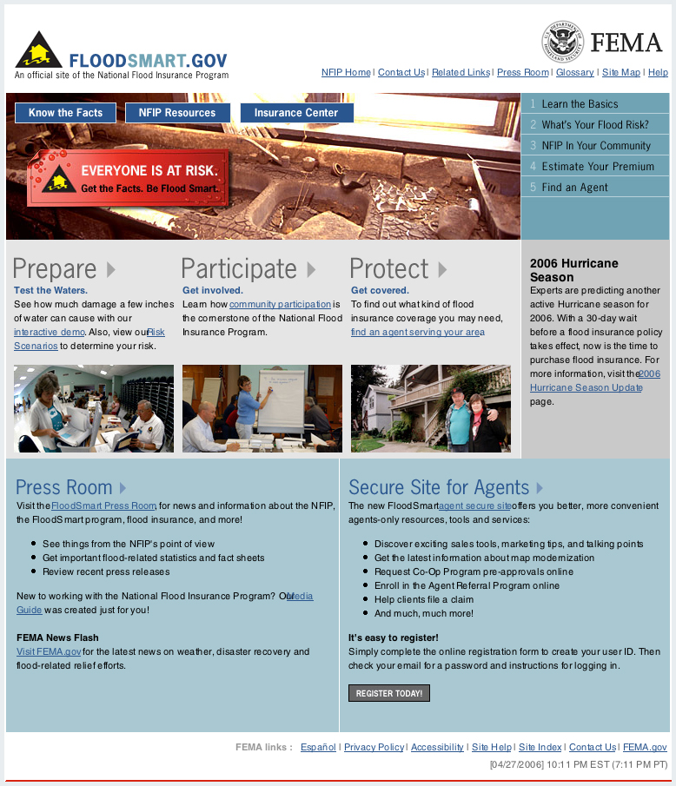
- Link to resources. Obtain information about floods, flood insurance, mitigation, disaster preparedness, maps, weather and natural resource conservation.


